PS 174 PA General Meeting
October 3, 2022, 6 p.m., via Zoom
https://nycdoe.zoom.us/j/92624690970?pwd=VFlYSXZtOWdzRG54eGNFN0tWUGhIZz09
Board Member Attendees:
Max Dickstein, Marc Lee, Anna Myers Sabatini
School Leadership Team Attendees:
School administration Attendees:
Total attendees (13 parents): Karen L, Marwa, Sonya Sakhrani, Gregory Arnold, Kyle, Elizabeth, Renee Frisch, Stephen Isaac, Silvia Germosen, Sandra Hoecke, A C, Connie, Romain Suinat
Call to Order: [6:06] pm

Please remember to sign in. The purpose of this meeting is to conduct the official business of the PS 174 PA.

I. Call to Order
- Begin recording, read previous minutes

II. Guest Speaker: Maria Rodriguez, Financial Aid Outreach Specialist, New York State Higher Education Services Corporation
- Discussed Excelsior, TAP, and NY’s 529 College Savings accounts, among other programs such as FAFSA - College - income based qualifications, there are info sessions sessions available nysaves.org/home/basics-of-529s/529-basics.html
startheregetthere.ny.gov/completing-the-fafsa
Email for more questions: ThePath@hesc.ny.gov

III. President’s Report
- Next School Leadership Team (SLT) meeting is 10/28
- Next Safety Committee meeting is 10/7

IV. Business
- Kindergarten Pumpkin Patch (10/31): Discussed purchase of 100 pumpkins for K
- 5th grade committee Karen - will lead with Yearbook, & Marc - Giselle -
- Fundraising Report
  - Manor Oktoberfest fun (9/21)
  - PA membership Dues drive
  - Manor Oktoberfest fundraiser September 21, 2022: $400 raised
- Slideshow of upcoming events presented
  - School Picture Day (Lifetouch): October 14, 2022, and December 2, 2022 (makeup day)
    - additional volunteers needed 10/14
Sonya, Sylvia, 4 parents needed total
  - Halloween Party: Sunday, October 30, 2022, noon-4pm: Call for volunteers and candy/drink donations https://signup.com/go/jEQechY
-Anna to research EventBrite fees
  - Election Day Bake/Snack Sale: November 8, 2022 — seeking parent volunteers to plan
Renee is interested, also Marc, Anna - Need change, napkins, plates, local bagel stores, donut shops? Big container for coffee, beverages - Zelle QR code - Square
  - Scholastic Book Fair: November 9-15, 2022: volunteers: https://signup.com/go/hocVYjT
    - Report from Chair Sonya Sakhrani
Bookfair from Nov. 9th–15th, need more volunteers, meeting for Chairperson and Executive Board with Jennifer - Sonya and Jeremy. First class coming in as early as 8:30am – 2pm, M, T, W, F. Last day needs a lot of volunteers. Lock up the library and register for the weekend. *Please emphasize to parents to send extra money for the tax. There will be an e-Wallet
  - Fundraisers
    - Jersey Mike’s fundraiser October 16–October 20, 2022
    - FlowerPower Amaryllis and Paperwhite sale in November
    - Movie Night
- Call for volunteers for newsletter committee, hiking committee, fundraising committee, gardening committee, etc.
  - Daffodil Project - call for volunteers, mid-October
- Amendment to bylaws re: tax filing (vote required at next meeting)
  - Add to Treasurer's duties:
“responsible for submitting, on or before the IRS deadline each tax year, Form 990 or other appropriate form on behalf of the Parent Association of PS 174Q, Inc.;”
V. Treasurer’s Report
- Monthly report, current state of funds (see screenshots below)
- NYC Ballet residency invoice & call for donations

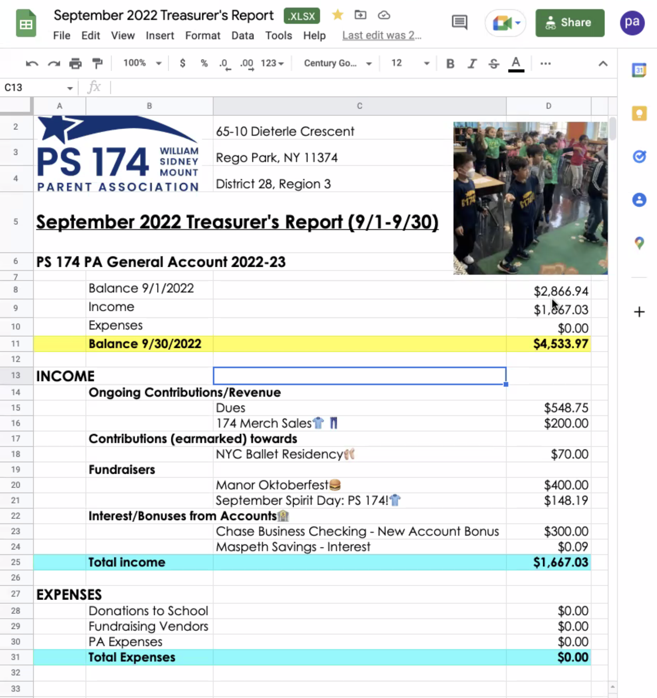
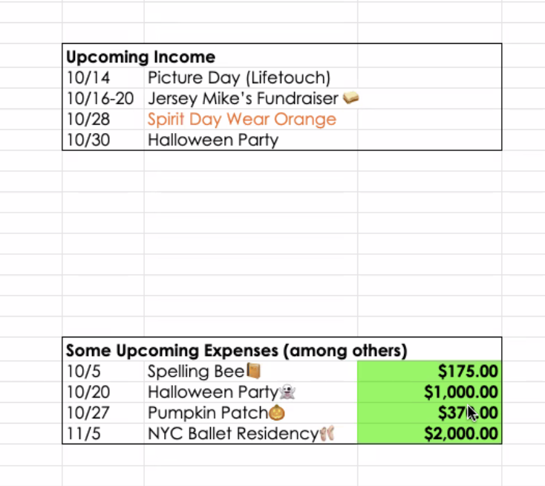

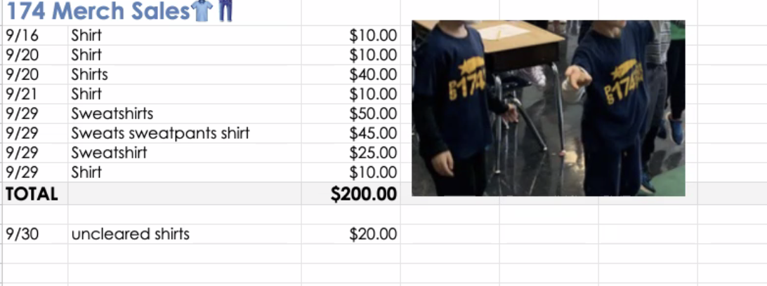

Recommendation - record small fee amounts on the Treasurer’s report
Connie - you get to see which classes pulling more weight - dues by class or grade?

World’s Finest Chocolate Fundraiser?

PS 174 Alumni Day fundraiser? (via Romain Suinat, Gregory Arnold, Max)

VI. Discussion

Movie Nights - Hannah looking into ways to do a movie night either at Cinemart or at the Auditorium at the school

VII. Adjournment
- Save chat, end recording - 7:11pm.

