Meeting Minutes
September 19, 2022, 6pm via Zoom*
Board Member Attendees:
Max Dickstein, Judy Wong, Marc Lee, Anna Myers Sabatini
School Leadership Team Attendees:
Judy Wong
School administration Attendees: Mrs. Karin Kelly, Mrs. Laura Hui
Total attendees (73 parents): Silvia Germosen class 121 421 521, Judy Wong, Frank Sabatini, Sonya Sakhrani, Erin Branum K & 2nd grade, Melanie Zhang, Marc Lee, Lauren Pemberton, Diana Lam-Hyunh, Daniella Douglas K and 3rd, Vivian Herel 4th, Asmaa Elgendy, Neena Gupta 3rd, Connie Ng, Winnie Ly 1st, Katerina Zuniga 1st, Maria Irene Garcia K, Alice Z/Celine Chen 1st, Seil Ling Tse K, Daleyln Wyszinski K116 & 2-201, Cherry Su 2nd, Lauren Pemberton 3rd, Jimmy Lakhani 2nd, Sandra Van Hoecke* 1st, Xioafang 1st, Fatima Arab Bafrani 1st, Marwa Hassan 1st, Anna Kosova 4th, Lucrecia Pilona K, Sharon L, Melanie Zhang K, Romain Suinat, Gregory Arnold & Hannah Trager K, Melissa Manrique 3rd, Angelina Fernandez* Romain Suinat* (501C3 help?), Giselle Chanona-Pierre 5th+, Romain Suinat, Vivian Herel, Eva Cheung,
*expressed interest in volunteering
+expressed interest in 5th Grade volunteering
Call to Order: [6:06] pm

Meeting minutes: Meeting minutes were read and approved
I. Call to Order
- Begin recording, read previous minutes
II. Guest Speaker: Principal Karin Kelly
- Welcoming remarks from Principal Karin Kelly: 17th Greeting to parents — read introduction of book, welcomed new and returning teachers, thanked teachers, substitute teachers and staff, including return of the Music program and new Art Room, technology access for the kids (DOE issued iPads with DOE educational apps only) starting with 5th grade, the return of free hot breakfast program starting Oct 3: 8am–8:15am, and the return of Field Trips for every grade. Instructional Celebrations with Parent engagement are also coming back. Meet the teacher days in September. Each month has Social/Emotional and Academic goals, with a focus on Student Centered approaches in instruction.
III. President’s Report
- Welcoming remarks from the Executive Board
- School Leadership Team (SLT) report
SLT is Composed of teachers, Staff, anyone who’s involved in the school, and parents are elected to it.
Judy: Last SLT meeting on Friday Sept. 19 — State Test Scores compared to the city’s scores: on average 3.33, the rest of the city in the high 2’s. What helps the school is the iReady program — primary difference — and wonderful teachers, who help prepare kids for the State tests.
- Safety Committee report
There are 4 lockdown drills for true emergency situations — 2 between Halloween and Spring Break, and 2 after spring break. Covid protocols: reporting cases, masks encouraged though not required, Following CDC guidelines, masks are available everywhere in the school. Remote learning is not set up for this year (for snow days or illness) there is no full-time remote teacher this year.
- Slide Show of PA-supported events
Judy Wong Shared slides to show the wonderful programs supported by the PA.
IV. Business
- Pumpkin Patch (10/31) - Kindergarten classes will go out to select pumpkins - (cost breaks even)
- 5th Grade Committee — graduation ceremony party — organizing needs to come from the parents of the eldest grade - Giselle Chanona-Pierre — to be 5th Grade Committee coordinator?
- Assemblies - any parents interested in booking assemblies
- Fundraising Report
  - PA Membership Dues drive
  - Manor Oktoberfest fundraiser September 21, 2022 - please attend
  - School Picture Day (Lifetouch): October 14, 2022, and December 2, 2022 (makeup day)
  - Jersey Mike’s fundraiser October 16–October 20, 2022
  - Halloween Party: Sunday, October 30, 2022, noon-3pm: https://signup.com/go/jEQechY
Discussed plans — and a call for volunteers. Separate meeting to be held to plan the Halloween party.
  - Election Day Bake/Snack Sale: November 8, 2022: seeking parent volunteers to plan
Bake/Snack Sale to sell refreshments to voters —
  - Scholastic Book Fair: November 9-15, 2022: https://signup.com/go/hocVYjT
Renee: Parents can volunteer to help children shop for books.
Sonya Sakhrani & Jeremy — taking the lead on the Scholastic BookFair this year, need help from parent volunteers to close up shop each day. Help from the PA to put in extra funds because the kids don’t have the tax money - include a reminder to include tax when announcing the BookFair.* Need a lot of volunteers to help kids select books within their budget — mornings especially — usually end off at 12/12:30pm.
Teachers can also have a wishlist and parents can purchase those books -
SHIRTS - soon to be available through PS 174 store on Smooth USA (*Note: since the meeting the vendor has not been able to meet demand, looking for new vendor).
Committees:
- Call for volunteers for newsletter committee, hiking committee, fundraising committee, gardening committee, etc.
Old Business:
- Amendment to bylaws re: tax filing (vote required at next meeting)
V. Treasurer’s Report
- Current state of funds
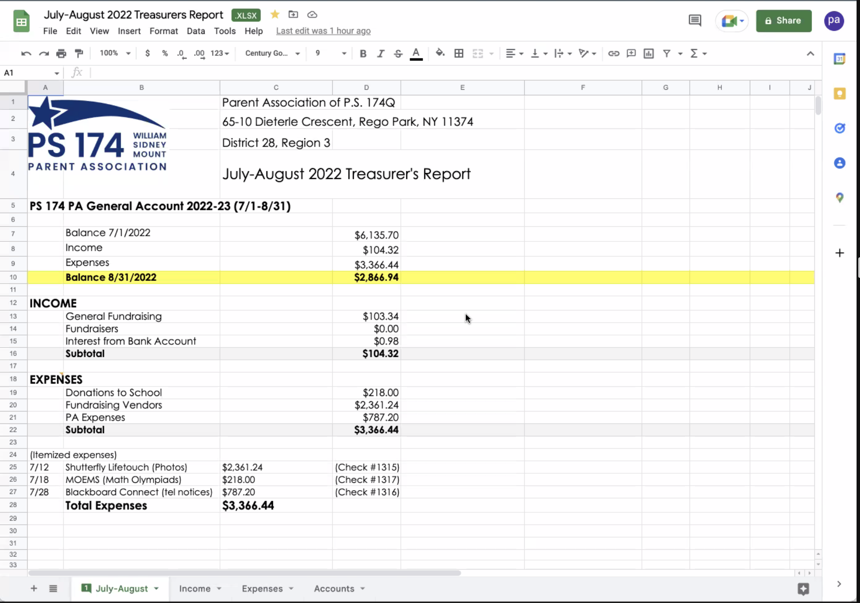

VI. Discussion
VII. Adjournment
- End Recording

Meeting adjourned: 7:15 pm

